Name: ____________________________________________________________ Date: ________________________

**Missing Angles: Solve for x.**

1. 2.

 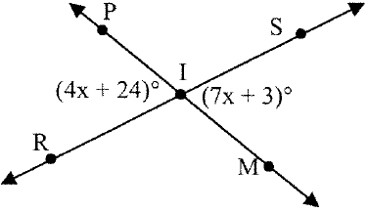

3. 4.

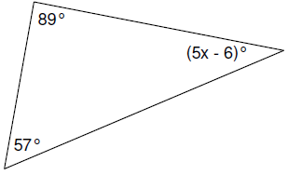 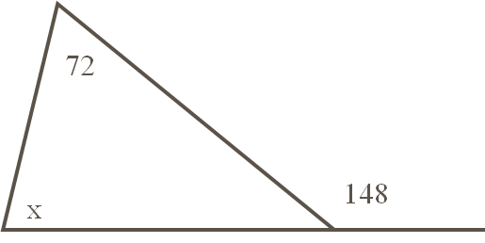

1. ∠1 and ∠2 are complementary. Solve for x and the measure of both angles.

∠1 = 12x + 4

∠2 = 9x + 2

1. The measure of one angle is 38 less than the measure of its supplement.

Find the measure of each angle.

1. One of two supplementary angles is 123° less than twice its supplement. Find the measure of both angles.

**Parallel Lines:**

Name the angles listed and the special property. 

8. ∠1 and ∠5_______________________________

9. ∠4 and ∠6 ______________________________

10. ∠2 and ∠8______________________________

11. ∠4 and ∠5______________________________

12. Given m||n and m∠8, find the measures of all the numbered angles in the figure.

m∠8 = 112

m∠1 = ______ m∠2 = ________

m∠3 = ______ m∠4 = ________

m∠5 = ______ m∠6 = ________ m∠7 = ________

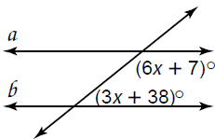

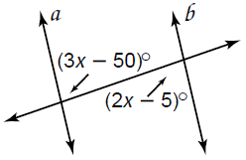**Solve for x.**

13.

14.

**Congruent Triangles:**

**Determine whether each pair of triangles is congruent (SSS, SAS, ASA, AAS, or HL). If not, write not congruent.**

15. 16. 17.

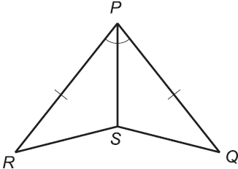 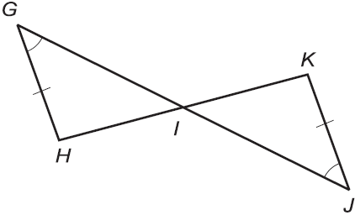 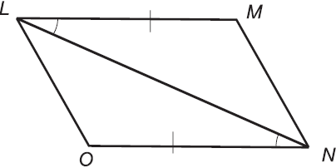

18. 19.

E

B

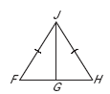



F

D

C

A

20. ΔABC  ΔDEF. What is congruent to ∠EDF?

21. Complete the following proof:

|  |  |
| --- | --- |
| **Statement** | **Reason** |
| 1. | 1. |
| 2. | 2. |
| 3. | 3. |
| 4. | 4. |