### Name: __________________________________________ Date: _____________________________

**Central Angles Homework**

**1. Identify and name each of the following from 🖸O. Be sure to use the correct notation. BD is a diameter.**

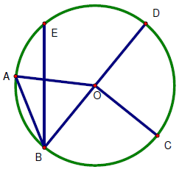

1. Two different central angles
2. A minor arc
3. A major arc
4. A semicircle
5. Two different chords
6. The central angle subtended by 



**Find each measure.**

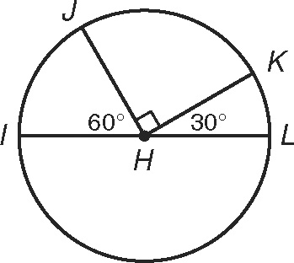

IL is a diameter.

2.  ________,_______

RU & QT are diameters.

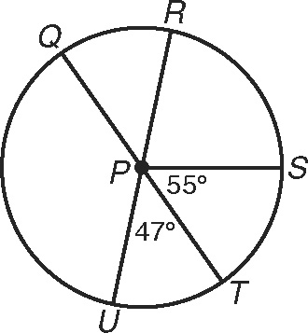

3. 

HE is a diameter

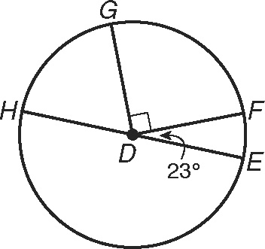

4. 

DA and FC are diameters.

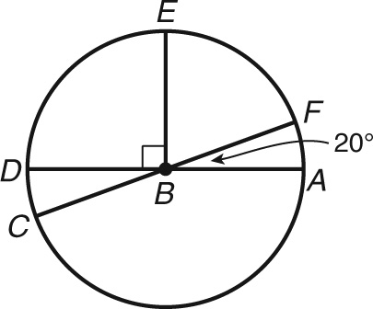

5. 

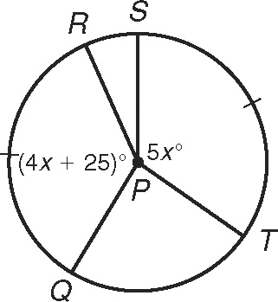

6.  ___________

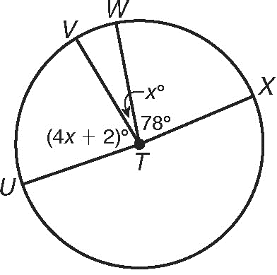

UX is a diameter.

7.  _______,________